END CAP



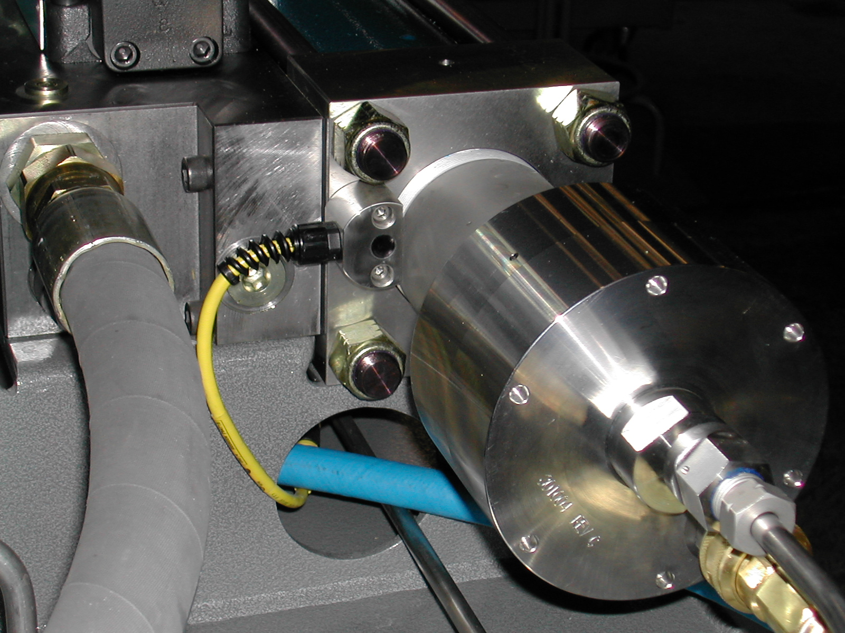
CHECK VALVE
CONNECT THE HIGH-PRESSURE TUBING AND WATER HOSE

8. Remove tools, parts, and rags from around the pump. Close the pump covers. Turn the pressure control knob fully counterclockwise to the lowest pressure setting and start the pump. Operate the pump at idle oil pressure for five minutes while checking for leaks and listening for any unusual sounds.

Hydraulic Oil Cylinder, Piston, Plunger, and End Bell Service

The double-acting hydraulic oil cylinder is located between two high-pressure water cyliders. When the cylinder and end bells require service, one or more of the following conditions are usually present.

a) Excessive oil leakage from the end bell weep hole or the joint between the cylinder and end bell
b) Worm piston seals aloowing excessive oil flow athe piston
c) A jammed piston or detached plunger

1. Disassembly of the hydraulic oil cylinder, end bells and piston involves the removal of the intensifier from the cabinet and a complete teardown of the intensifier on a workbench. An experienced technician using the proper tools and procedures can usually complete the procedure in 2 ½ to 3 hours. The intensifier assembly fixture is required for this procedure. The fixture is used during the reassembly process to align the end bells square with each other and to minimize the possibility of O-ring damage as the cylinder is being drawn onto the end bells. When the end bells are assembled out of alignment, oil manifold leakage and breakage may occur.

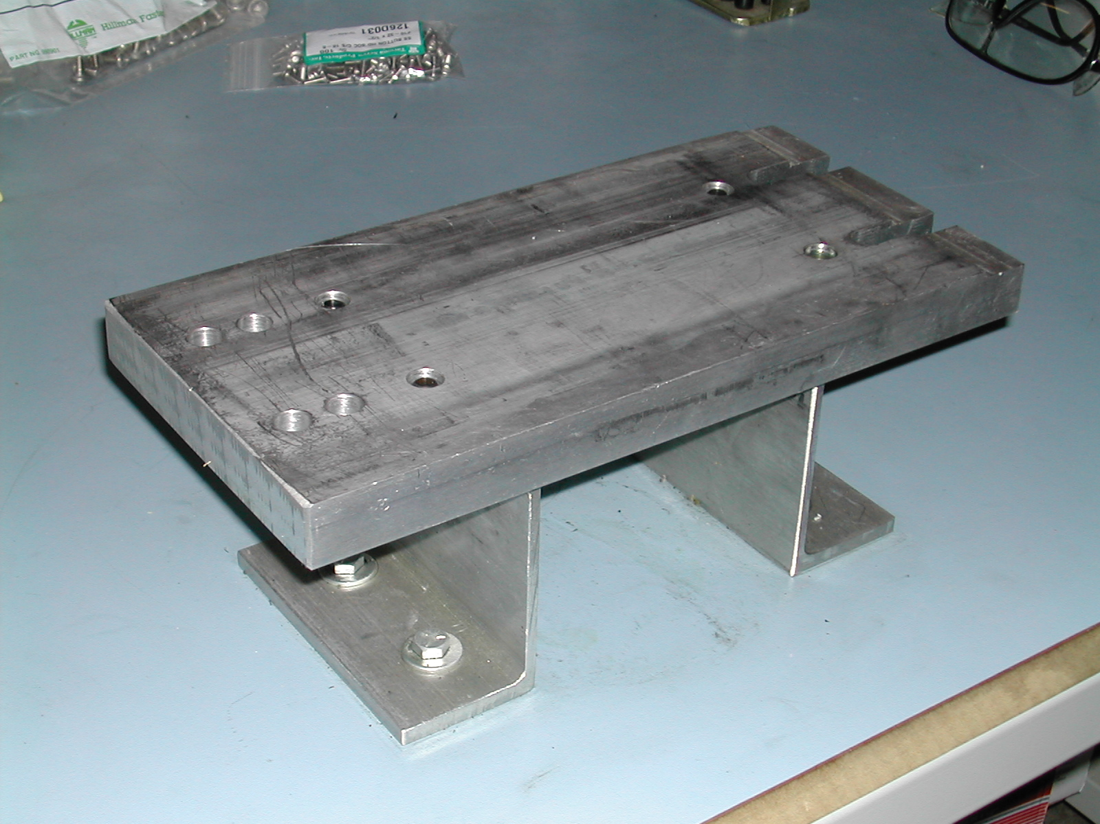

2. Shut down the system. Disconnect the supply water hose at the quick-disconnect fittings. Using two wrenches, disconnect the high-pressure water line from the check valve outlet body. Loosen the other end of the tubing and move it out of the way
3. Remove the four allen screws securing the shift cable housing to the pilot valve and end bell.
Mechanical shift:
SHIFT CABLE

PILOT VALVE

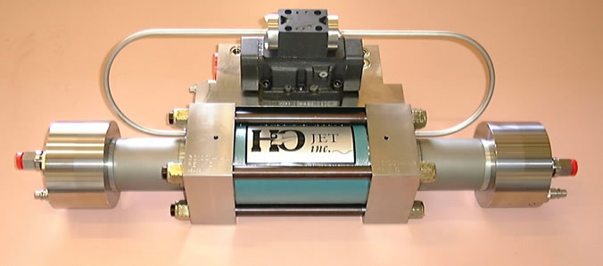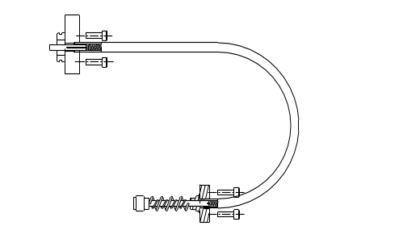
SHIFT CABLE

END BELL

Electric shift:

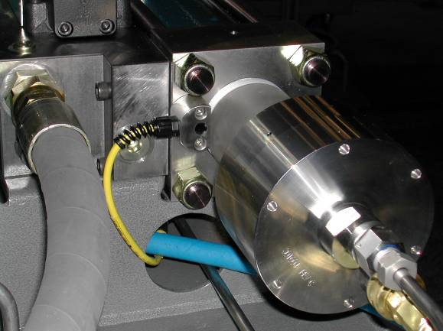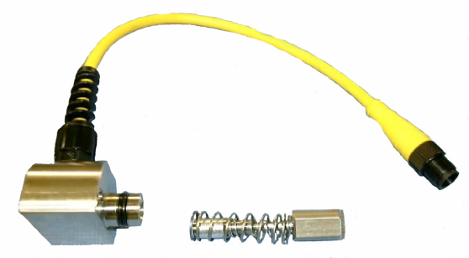

PROXIMITY SENSOR

ACTUATOR ASSEMBLY

4. Remove the shift cables and actuating pins from the intensifier and set aside. Use the Shift Pin Tool to remove the shift pins. The shift cables can easily damaged and are removed for protection only.

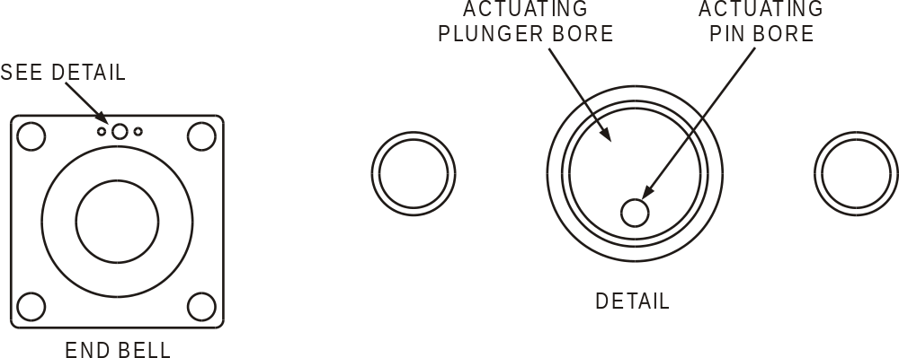

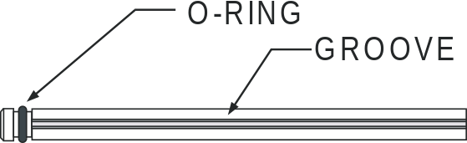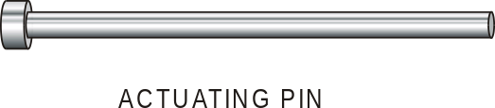

5. Remove the oil supply and drain lines at the manifold elbows, and plug to minimize oil loss. Approximately one quart of oil may be lost when the above parts are loosened and removed.

6. Remove the mounting cap screws securing the intensifier to the manifold. The intesifier must be free to be removed from the cabinet.

7. Loosen the bolts and remove the intesifier from the manifold. Drain oil from the intesifier ports.

8. Mount the intesifier assembly fixture to the workbench and place the intesifier on the assembly fixture with the manifold surface facing down. Screw the intesifier to the fixture using the provided screws. Remove the torque from the cylinder tie rods evenly using two wrenches (do not use a torque wrench) in a figure-eight pattern. Remove the nuts and tie rods.
MANIFOLD

NUTS

TIE RODS

9. Remove the cap screws that hold one end bell to the intesifier assembly fixture and, using a mallet, tap the end bell free of the cylinder. Remove the end bell and set it aside.

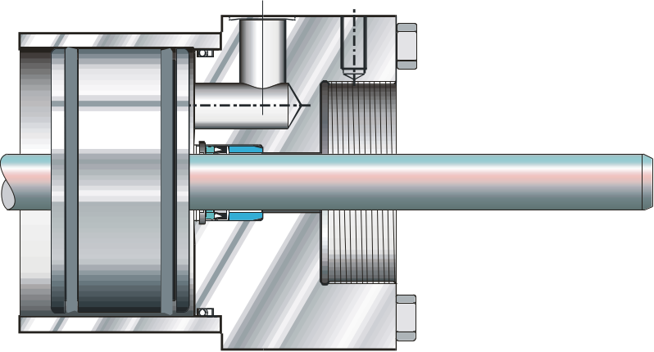
REMOVE TIE RODS

END BELL

REMOVE THE END BELL

- Remove the cylinder from the other end bell. The piston and plungers may remain with the cylinder

HYDRAULIC PISTON

REMOVE THE CYLINDER

HYDRAULIC CYLINDER

11. Drive the piston and plungers from cylinder with a soft-faced mallet and set the parts aside.

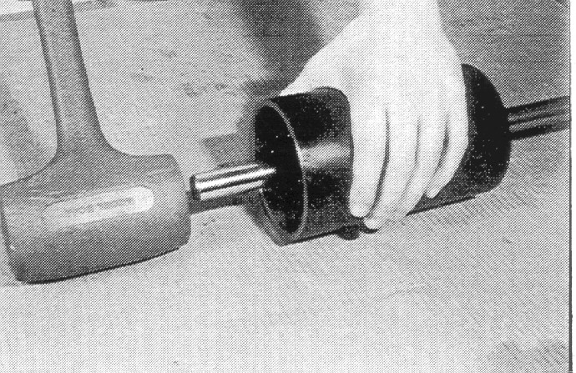

12. Begin the inspection of the hydraulic cylinder, end bells and related parts at this point. All service must be completed in a clean, well-lit area.

13. Remove the snap ring, spacer and seal from the end bell, but do not use a sharp instrument as it will damage the parts.

14. Clean the end bells, seal spacers and snap rings and inspect each part.
a) Check the end bells for damaged threads, a damaged or out-of-round shift actuating pin hole, and damage to the sealing surfaces and grooves.
b) Make sure the seal spacers are not ouf of round, warped, or nicked.
c) Make sure the snap rings are not bent and still have the approproate tension.

15. Apply clean hydraulic oil or Parker Super O-Ring Lube to a new oil seal and install it in an end bell with the flared (o-ring) side visible. Place the spacer on top of the seal and install the snap ring.

LOW PRESSURE SEAL KIT
SNAP RING
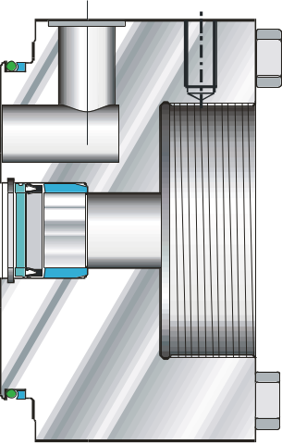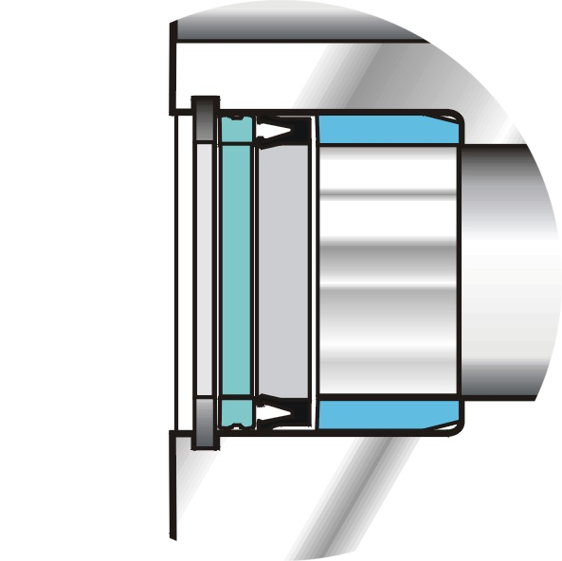
SPACER
OIL SEAL

16. Apply clean hydraulic oil or Parker Super O-Ring Lube to the new backup ring and note which face of the backup ring has light circular molding marks. Lay the end bell flat and install the backup ring on the end bell with the molding marks facing the end bell. Lubricate the new o-ring and place it in the groove on top of the backup ring. The o-ring must be to the outside of the backup ring, towards the low-pressure cylinder side.

O-RING

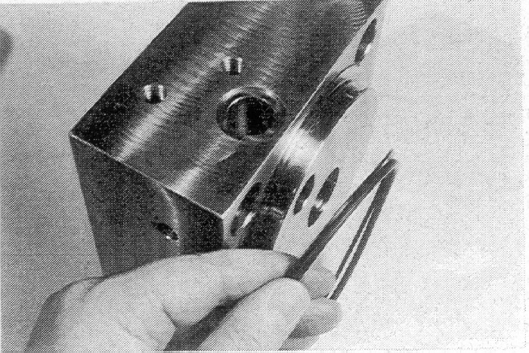
BACKUP RING AND O-RING
BACKUP RING

17. Repeat Steps 15 and 16 for the other end bell, then set the end bells aside and cover with a lint-free cloth.

18. Clean and inspect the hydraulic oil cylinder. Inspect all surfaces of the cylinder for any signs of damage or fatigue. Inspect the inner diameter by looking through the cylinder angled toward a brightly lit white surface. Any damage to this surface must be polished out. If this is not possible, the cylinder must be discared.

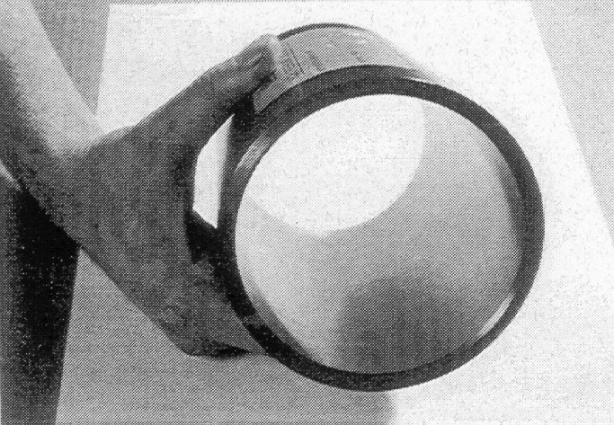
HYDRAULIC CYLINDER

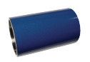

- Remove the snap ring and retainer. The retainer can be loosened by blowing air down between the plunger and the retainer bore.

- Remove the plunger by hand.

SPACER
SNAP RING

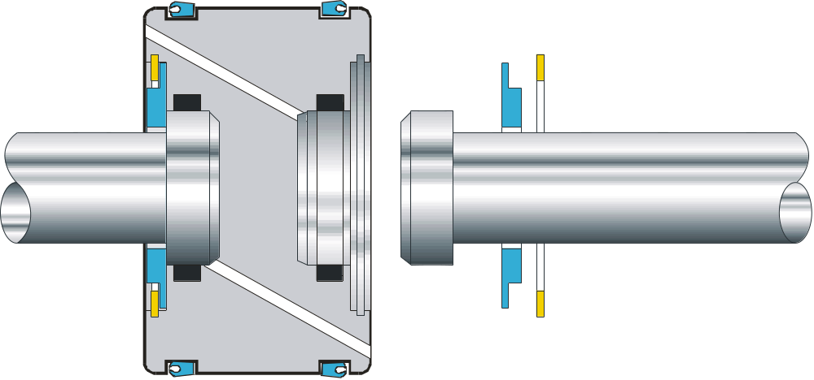
PLUNGER
PISTON SEALS

21. Repeat Steps 19 and 20 for the other plunger. Set the plungers asside.

22. Apply clean hydraulic oil or Parker Super O-Ring Lube to the head of the plunger. Install plungers into the counter bores in the piston biscuit with a turning motion. Ensure that T-seals or O-rings do not get nicked or rolled.

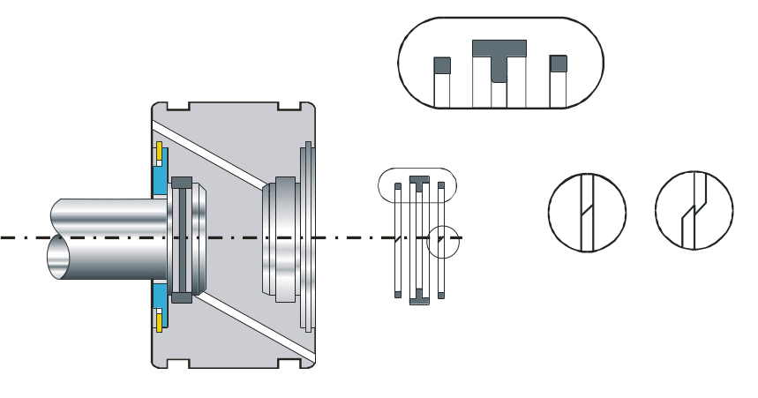
GROOVES
T-SEAL
CORRECT
INCORRECT
BACKUP RINGS

23. Slide the piston and plunger assembly containing one seal into the cylinder oriented so that the empty groove enters the cylinder first.

24. Slide the piston into the cylinder until the empty seal groove on the piston appears out of the other end of the cylinder.

25. Apply clean hydraulic oil or Parker Super O-Ring Lube to the seal and install it in the groove oriented with the flared o-ring face towards the outside of the piston

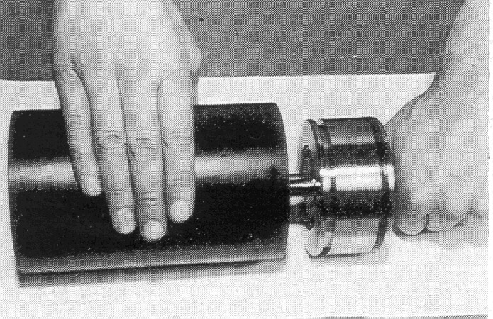
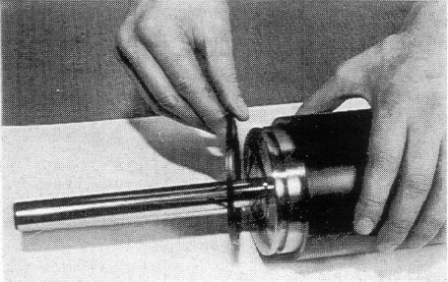

26. Mount the remaining end bell to the plunger and secure to the assembly fixture with the cap screws finger tight

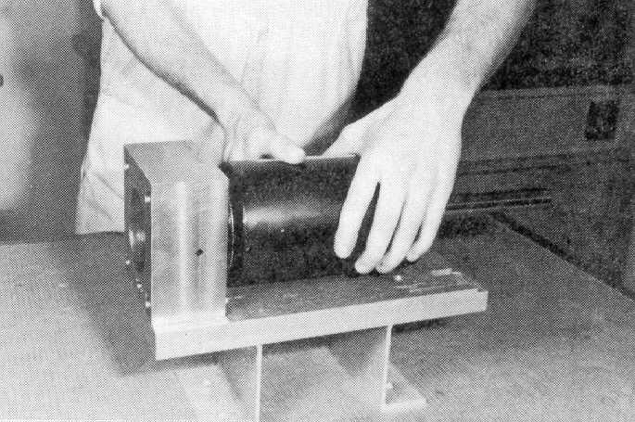
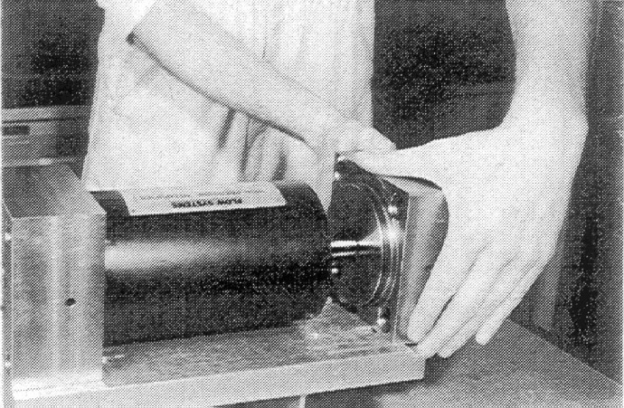

27. Install tie rods and thread on the elastic stop nuts

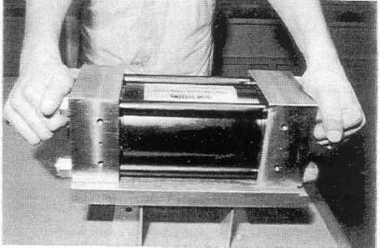

28. Draw the cylinder carefully onto the end bells by tightening the nuts evenly in a figure-eight pattern while moving end to end. Seal or backup ring debris must not appear at the cylinder/end bell interface. Check for any sign of a problem before continuing. Torque all nuts evenly to 20 ft-lb. (27 N-m) so that all parts are seated.

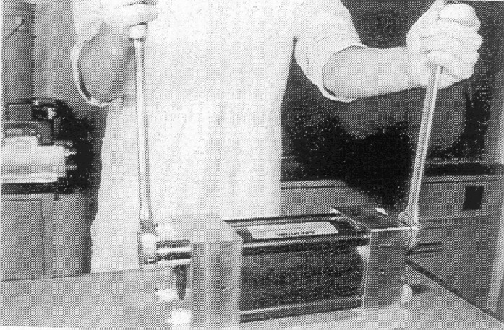

29. Install the high-pressure water cylinders and end caps.

END BELL

END CAP

HIGH PRESSURE CYLINDER

CHECK VALVE

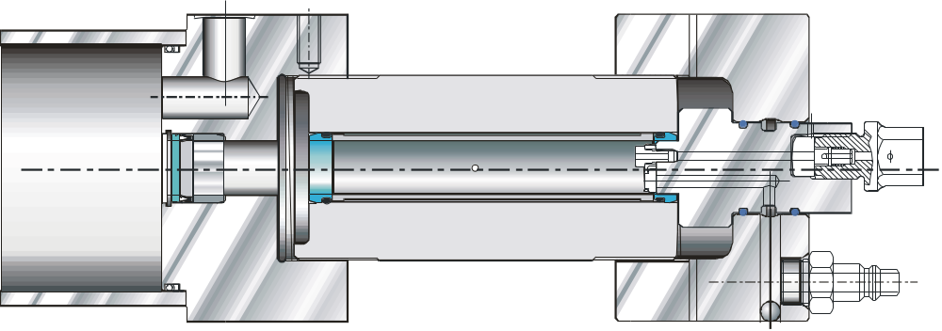

CONNECT THE HIGH-PRESSURE TUBING AND WATER HOSE

